

presents
WITHOUT BLOOD
a film by Angelina Jolie
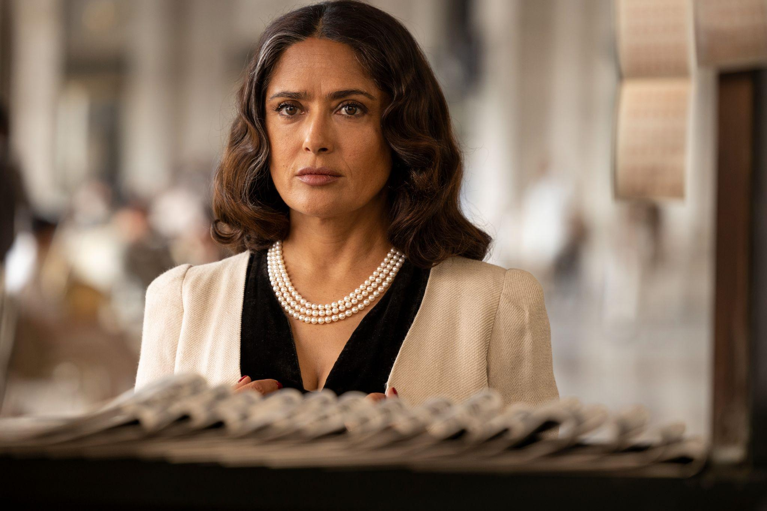

2024 // USA, ITALY // ENGLISH // 91 MINUTES

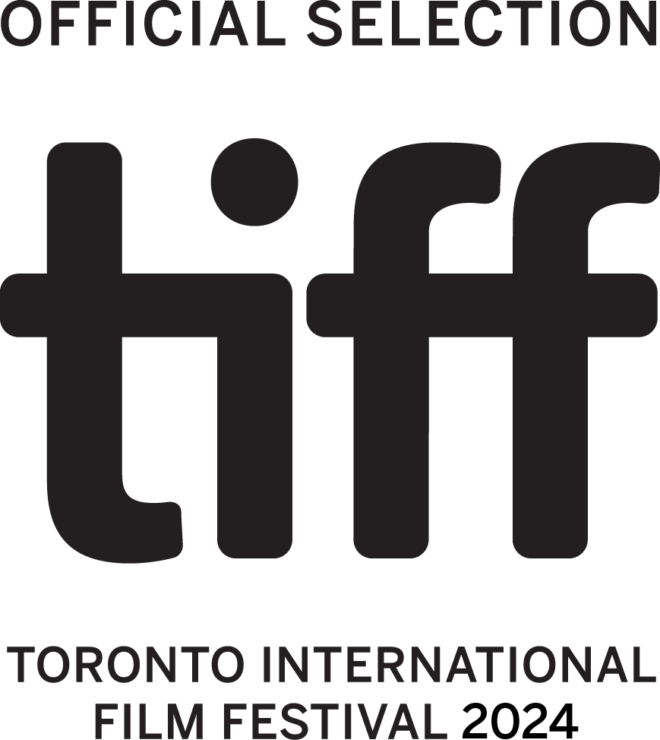

WORLD PREMIERE
Special Presentations

Festival Screenings:
Sunday, September 8, 9:45PM | World Premiere Screening – TIFF Lightbox Cinema 1
Monday, September 9, 9:00AM | Press & Industry Screening – TIFF Lightbox Cinema 2
Tuesday, September 10, 9:45PM | Public Screening 2 – Scotiabank Theater 2
Thursday, September 12, 9:15PM | Public Screening 3 – Scotiabank Theater 11
Friday, September 13, 6:00PM | Public Screening 4 – Scotiabank Theater 8

Press Materials:
https://tinyurl.com/WITHOUTBLOODPressMaterials

Publicity – Obscured Pictures  withoutblood@obscuredpictures.com | Sales – CAA  Roeg Sutherland | rsutherland@caa.com  Christine Hsu | christine.hsu@caa.com
Fremantle Contacts
Matthew Sanders | Matthew.Sanders@fremantle.com
Sereene Brown | Sereene.Brown@fremantle.com

SYNOPSIS

Written, directed, and produced by Angelina Jolie, Without Blood is based on the acclaimed international bestselling novel by renowned Italian writer Alessandro Baricco. An unforgettable saga set in the aftermath of an unidentified conflict, it explores universal truths about war, trauma, memory, and healing.

Q&A WITH THE DIRECTOR

Why did you want to make ‘Without Blood?’

Well, it’s based upon the book ‘Senza Sangue’ by Italian author Alessandro Baricco, and I first read it almost eight years ago during a very particular time in my life. And it really took me on the journey that I hope to take the audience on in the film. I made certain assumptions when reading it about how narratives usually go, but this book had taught me something by the end. When I finished ‘Without Blood’, I just felt like the story was truthful. It was true to what I had experienced with people who survive conflict, and any experience I had myself with trauma, however small in comparison. So it's become an important book to me.

You also met Alessandro Baricco as well, didn’t you?

I did. And he came to the set during the filming, but I also met him when I was adapting it. I’ve been very faithful to his book. It was hardly me writing it. I remember Alessandro saying to me, ‘My books don’t translate easily, and you might be pressurized to define a country, define a conflict, potentially define an end.’ But to the credit of my producers, they didn’t. I know that could be part of what’s hard to watch, but it’s hard for people to live it. It's hard to not have answers. It's hard to know that there is no end to certain horrors or pain that have transformed and affected your life. I think at the end of the day, the film takes seriously the effects of these conflicts, especially on children. There’s a lifelong effect on human beings and on society. It’s not just the bomb that goes off, it’s the entire fabric of the body, the mind, the spirit, and also the society, the country.

How does your work with refugees and survivors of conflict help you understand human trauma?

I think as a human being, I’ve been trying to understand a lot about injustice and cruelty, and I’ve probably been lifted in life and survived this life myself because of the inspiration of the extraordinary survivors and the kindness of others across the world who have nothing and give everything. What I know is however you fight through it, however you help each other through it, trauma never leaves your body and you are forever changed. When I visit a refugee camp or watch the news, I don’t think about it as a moment in a person’s life. It will forever alter the course of their life. And whether there is justice or not, it will affect decades on from now how people, countries and our world make choices.

And this isn’t the first time you’ve directed a film about war and conflict…

Yes, the first time was ‘In the Land of Bloody and Honey’, that was me trying to understand the war in Yugoslavia, which happened during my lifetime, people who were friends and lovers and neighbors then went against each other and were divided and are still quite divided. The whole project for me was trying to learn about what happened and how's that possible. And the second war film, if you will, was ‘Unbroken’. How when you're within the war, how does the human spirit deal with war and capture and somehow come out of it with their spirit intact and their humanity intact. The third is, ‘First they Killed My Father’, which is about how the innocence of childhood is affected by war. And this is like a final chapter of the first film that's about post-conflict. How many, many years later, where did it all settle? Did they just walk away with their humanity and their heads up and survive it? Was there ever justice? What happened? That's why I think Alessandro’s book mattered to me and spoke truth to me, it was a final understanding that brought me all the way back to the beginning of why it's so important to try to prevent conflict in the first place.

The use of the Spanish language in ‘Without Blood’, perhaps even the period setting, might give viewers some ideas about whether it references a particular conflict?

Alessandro said to me the events mentioned in his original story are imaginary. The frequent choice of Spanish names is due purely to their musical sound and not intended to suggest the historic or geographical location of the action. Having said that, the language does of course influence the story. Even though I didn’t place it somewhere specific, I did think about having actors who would give the language consistency. The actors are mostly of Mexican or Latin American origin and that might suggest something to the audience. I did also give a thought to what was going on in these places during this time period. However, although I think the Mexican Revolution (1910) is a very interesting time in history for instance, it’s not Mexico at this time.

Why did you choose Salma Hayek for the role of Nina as an older woman?

Salma and I had never really met, but we then worked together on a fun film together, ‘Eternals’. I got to know her a little bit, and I found her a very warm, thoughtful person. She’s a deeply thinking human. I wanted to get to know her more deeply, and I feel like in ‘Without Blood’, this maybe is more the Salma I know, than the Salma people think she is. And she was very open and very brave in her performance, she was just present as a person having a time to reflect on her own understanding of loss or pain.

And why did you choose Demián Bichir to play older Tito?

Demián was total in his commitment, and he was aware of Alessandro Baricco’s work. There's a lot today where you can hide yourself as an actor. A lot of cuts, a lot of action, fun things. It’s quite something to ask actors to sit there and be open and as a director say, ‘I’m going to give you the space to do what you do, but you have to be fully present as I will notice everything you’re thinking and I’m not leaving.’ As an actor myself, I’d see it as an opportunity to bare my soul but also, you cannot falter. He and I had spoken about this, and both actors brought a lot of good questions, research, in-depth study and that was exciting to be around. All the cast were so dedicated, hardworking and serious about their craft.

A lot of the drama in ‘Without Blood’ takes place as a conversation between these two actors, at a table. How did you direct it?

We shot the table scene in order, which was quite interesting. It took around ten days to shoot, not that long because it was very intensive. Salma and Demián felt like two boxers coming into the ring every day. They’ve known each other for a long time, but not like this. But even though the two of them hadn’t caught up in a while, they didn’t socialize with each other until the last day and the whole movie was over. Then I saw them talking and laughing together, but they didn’t do it during the shoot. They stayed in their corners and met at the table. We didn’t plan any reactions, and a good actor doesn’t need that. A good actor has no idea what's going to come out, and they just listen to the person across the table, and they allow themselves to be affected. So there were things that happened that were happening in real time that viewers experience when they watch it.

How did the last scene at the table play out?

I remember the morning of filming the final moment in the cafe and Salma was angry. She’d woken up with this feeling that Nina had never gotten a true apology. it made me think of all the people I know. We all have people in our lives who've really hurt us, who've never truly apologized, truly. But I didn’t say that - we just talked about the importance of being open and honest as a woman. In the scene, she’s just completely warm and open to Tito. She breaks from or trying to question or punish him, and she says something that confirms their connection and their history and that he meant something to her. That’s what breaks him. So, he can’t stop crying, and then Demián improvised something that was unplanned. He just said, ‘I'm sorry.’ I didn’t tell him to say that, and he didn’t know Salma’s thoughts either. We all walked away from that thinking, ‘we’ve all learned something about relationships.’

Although Tito was present at the murder of Nina’s father, do you see a certain nobility to him as a character?

It meant a lot to me when I read it, that the male character at no point makes excuses. He defends his position and his belief, but there’s no excuses. He never says, ‘I didn't kill anybody, and I was a child too.’ He could have defended himself better, but he doesn't. And there's something very noble and right about it. What matters is how it affected her and how she lost her family. He gives her a great gift to let her do what she does through that film and to the end.

Are both Nina and Tito victims of this war?

The interesting thing is how Nina is being seen by audiences. It was a real lesson to me, because as a woman, I feel that I'm being told you are only okay if you forgive everybody that hurts you and walk with grace. That's the lesson I got in my life. So, I’ve been a little bit shocked when we’ve screened this and found many people are on Nina’s side. So is it that somehow we've brought you into that little girl's eyes and her pain, you saw her with her dad, and you’re able to sit with Salma? I was so confused. I remember saying to Salma when Salma said, ‘he needs to apologize.’ I said, ‘right, but do we know what is happening here? This man lost his family, was a boy, here's a little girl, he tries to save her life, then spent his whole life in fear, loses the only people he knows, sits humbly in a kiosk, just basically not existing his whole life because of this. He’s tired, he’s basically saying, “just kill me.” ‘I’m fascinated about the way audiences are perceiving Nina, because if you think about it, she grew up to become exactly like the guy who killed her dad.

Do you see ‘Without Blood’ as part of the Western genre of filmmaking?

I love that it’s been called a western genre piece, I never realized I did a western. But I think it was definitely on my mind in some ways. I'm very conscious when I do anything to do with conflict or death or war, I don't shy away from what it looks like to really be shot. I don't try to be gruesome, but I try to be accurate, because I think to be less than accurate is a disservice to what death really is. But I'm always a believer that when you do very hard stories, you don't want to also punish the audience by making it hard to look at. There's a reason why the table they're sitting at gets warmer. It was intentional that the harder things would get, the night would fall, the candles would be lit, because I imagined if that table was cold, like a metal table, and the cold light of day in those conversations, that's a harder table to sit at for the audience. It needed that fireside chat feeling. There’s also something of the beauty and expanse of the land in the film that’s also true to westerns. Whether it be the horses, the nature of the sky, the dust and dirt, these are very beautiful textures.

How was it to shoot ‘Without Blood’ in Italy?

Oh, I loved filming in Italy, it was a beautiful sharing between the actors and the crew, plus there’s a lot of overlap in the cultures. It was a real pleasure to shoot there. It adds a lot of texture to be in such a country with a rich creative world and love of art and cinema. It inspired me in the sense of what could be considered, say, a beautiful café or a beautiful piazza, in the film. These two cultures coming together for the shoot just felt very natural.

Can you talk about how sensory the film is and what you wanted to evoke?

I'm very specific about color when I direct. I think I'm very affected by colors which may be why I wear black a lot, and in fact most directors are affected by color and use it sparingly. There were a lot of things that hopefully I didn’t do in a way that looks like a gimmick or a trick, but much of this film is about how memory is triggered and how it sits in the body, and there’s been a lot of study on that. Sometimes the sound of the spoon on the table is what leads Nina to the hospital where she was kept, or the light or the candle on the table is a real moment, because fire is very significant to both of them. Nina’s actually unable to call up memory at the beginning and that’s how trauma really works. Sometimes when you’re too close to it, you can’t let the memory flood in. And it is only in the end that she fully remembers seeing her father. It's only in the end when she lets the memory come back.

FILMMAKER BIOGRAPHIES

ANGELINA JOLIE | DIRECTOR
Angelina Jolie is an Academy Award-winning actress and director, with numerous film credits including Walt Disney Pictures’ Maleficent series, Salt and Girl, Interrupted, and the upcoming Pablo Larrain-directed Maria.

Jolie has directed, produced and co-wrote the critically acclaimed First They Killed My Father, as well as directed the Oscar-nominated Unbroken, among others. She is a Tony-award winning producer on the acclaimed new Broadway musical, The Outsiders.

With over 20 years working as a humanitarian focusing on work with refugees and human rights, Jolie also champions local leadership in environmental conservation, and has funded schools, health and education initiatives globally. Additionally, she is Founder of the Maddox Foundation, an integrated development program headquartered in Cambodia, with a focus on conservation, agriculture, education and economic development projects in the area.

She is the founder of Atelier Jolie, a hub for artists, empowering people to participate in creating their own fashion, with a focus on sustainability. Jolie is also co-author of Know Your Rights and Claim Them, a guide for youth.

PRODUCTION CREDITS

Angelina Jolie  Seamus Mcgarvey  Xavier Box  Joel Cox  Roberto Malerba  Michael Vieira  Elena Recchia  Angelina Jolie  Lorenzo Mieli  Lorenzo De Maio  Simone Gattoni  Fremantle North America  The Apartment  Jolie Productions  Fremantle  De Maio Entertainment  Ursula Patzak  Angelina Jolie  Alessandro Baricco  Angelo Bonanni  Rutger Hoedemaekers | Director  Cinematography  Editor  Editor  Executive Producer  Executive Producer  Executive Producer  Producer  Producer  Producer  Producer  Production Company  Production Company  Production Company  Production Company  Production Company  Production Designer  Screenplay  Screenplay  Sound  Original Score

CAST
Salma Hayek Pinault  Demián Bichir  Juan Minujin | Cast  Cast  Cast

###

